Calculator Complete

Course: PROG2200

Student: Artem Fedorov

ID: W0461394

Instructor: David Kristiansen

12.11.2023

Contents

JavaDocs 3

Class diagram 3

Sequence diagram 4

SOLID table 5

# JavaDocs

*see the Javadoc folder in the same folder.

# Class diagram

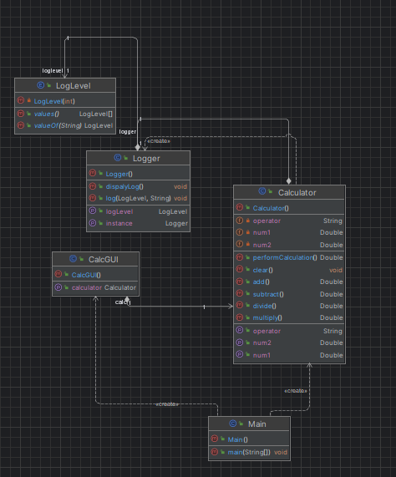

# Sequence diagram

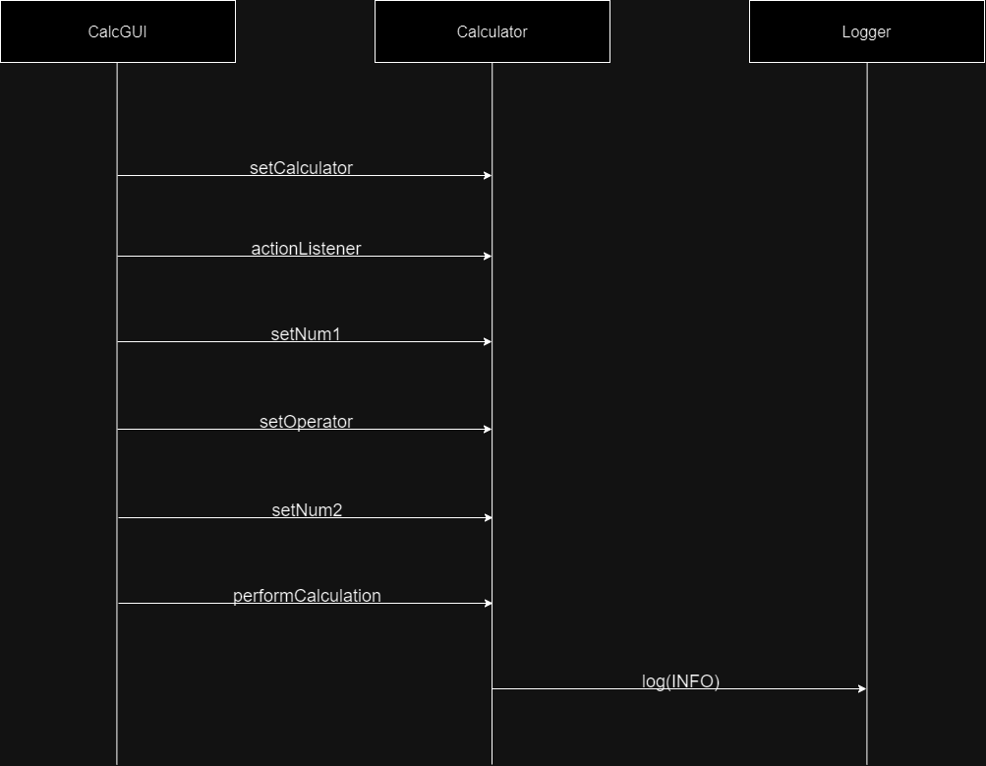

# SOLID table

|  |  |  |  |
| --- | --- | --- | --- |
|  | **Acronym** | **Concept** | **My Application of the Concept** |
| S | SRP | Single responsibility principle | **Calculator** class responsible only for handling calculations; **Logger** class responsible only for logging. |
| O | OCP | Open/close principle | We can create new operators or functionality in **Calculator** class without changing existing code. |
| L | LSP | Liskov substitution principle | We can create new class that extends **Calculator,** and it should be usable whenevera **Calculator** object is expected. |
| I | ISP | Interface segregation principle | If we have interfaces for different functionalities (like CalculatorOperations) we need to make sure that classes only implemented interfaces relevant to their functionality. |
| D | DIP | Dependency inversion principle | **CalcGUI** class do not depend the details of low-level modules (**Calculator**) |